Products to Help with Skin Concerns
Name | Picture | Where to Get it
Moleskin | 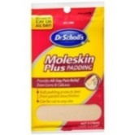 | Drug Store, WalMart, Target, Amazon
Blister Band Aids | 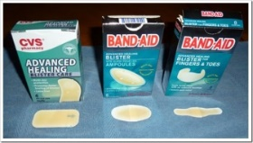 | Drug Store, WalMart, Target, Amazon
Band Aid Friction Block | 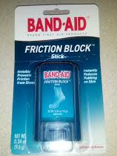 | Drug Store, WalMart, Target, Amazon
Molefoam | 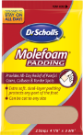 | Drug Store, WalMart, Target, Amazon
Non-medicated Corn Cushions | 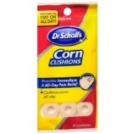 | Drug Store, WalMart, Target, Amazon
Duoderm | 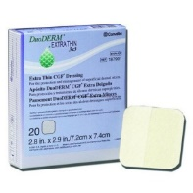 | Amazon  *ask your pediatrician to write you a Prescription
Bacitracin Ointment | 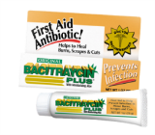 | Drug Store, WalMart, Target, Amazon
Round Cosmetic Sponge | 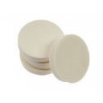 | Drug Store, WalMart, Target, Amazon, dollar store
Pressure Saddles | 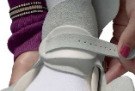 | www.mdorthopaedics.com  1-877-ponseti
Calmoseptine cream | 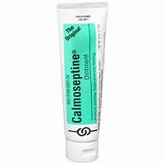 | Drug Store, WalMart, Target, Amazon
Sheepskin | 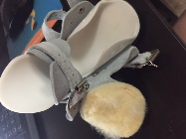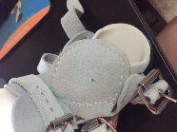 | Ask your orthotist to sew sheepskin to the tongue
AliPlast foam | 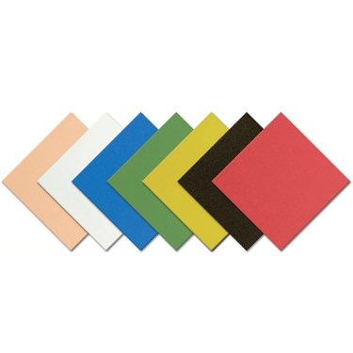 | Amazon, ask your orthotist
Padded Heel Liner | 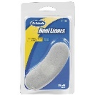 | Drug store, Target, Walmart, Amazon
*Other recommended products: ReSkin, 2nd skin dressing, Mepilex, silicone scar gel sheet, Skin Prep wipes (preventative), Tegaderm foam
*Disclaimer*The information provided is from clubfoot family experiences, and the medical community. Doctors and those in the medical field have opinions that may differ. This document is not a substitute for professional medical advice. Consult your doctor with questions. Every clubfoot situation and every clubfoot child's treatment plan may differ slightly.

